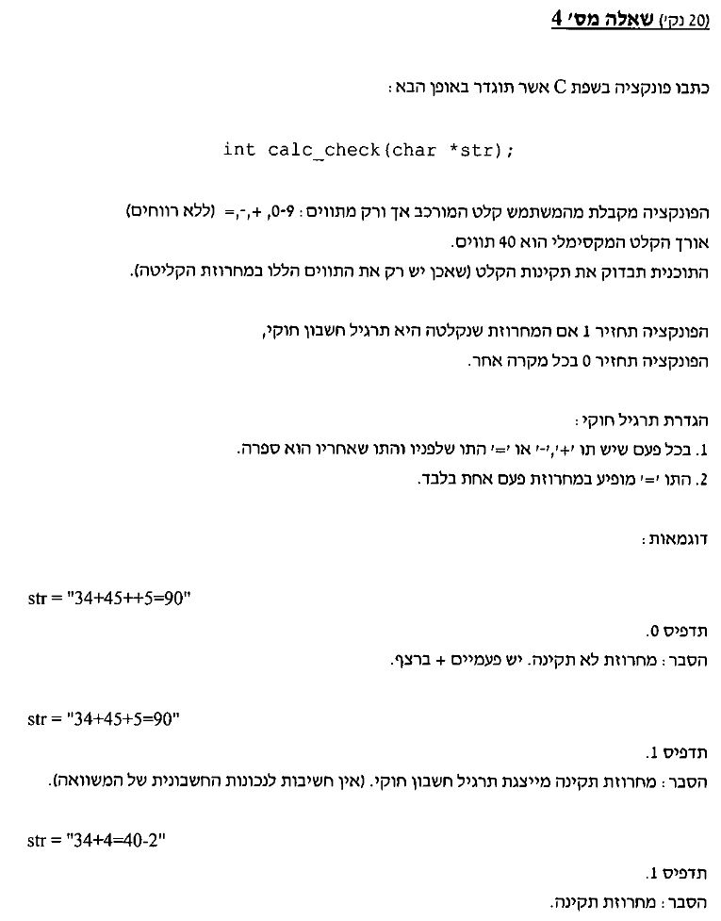

תשובה:

#include<stdio.h>

#include<stdlib.h>

#include<string.h>

#define size 40

#include<ctype.h>

int calc_check(char *str)

{

for (int i = 0; i < strlen(str); i++)//go over the string

{

if (str[i]=='=' || str[i]=='+' || str[i]=='-' || str[i]=='*' || str[i]=='/') //check for any +,-,*,/,= signs in string

{

if (str[i+1] == '=' || str[i+1] == '+' || str[i+1] == '-' || str[i+1]=='*' || str[i+1]=='/')

//if any is found, check if the character after is the same and if so, return 0

{

printf("wrong input\n");

return 0;

}

}

if ((str[i]<'0' && str[i]>'9') || (!isalpha(str[i])))

//check if numbers are between 1 to 9 and if any character in the string is a letter, if so then return 0

{

printf("wrong input\n");

return 0;

}

}

puts(str);

return 1; //if the string is ok, return 1

}

void main()

{

char str[size];

int status;

int count = 0;

printf("please enter a string with 0-9 and +,-,*,/ only!\n");

gets(str);

status=calc_check(str);

printf("%d\n", status);

}